1. Collections Class:
   1. This class contains static methods exclusively.
   2. Methods
      1. To sort underlying collection.
      2. To shuffle
      3. To reverse
      4. To get synchronized version.
      5. To get unmodifiable version.
2. 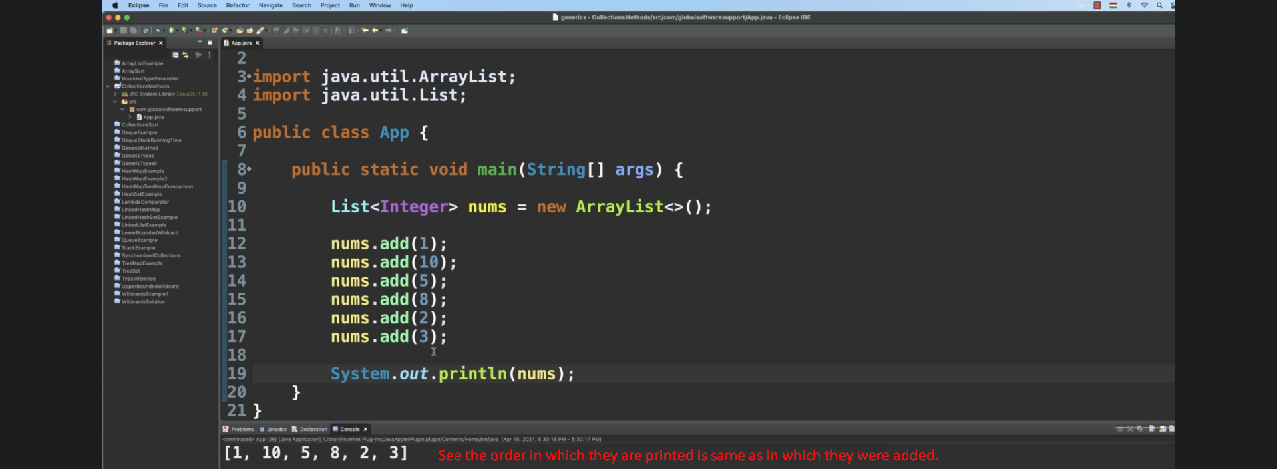
3. 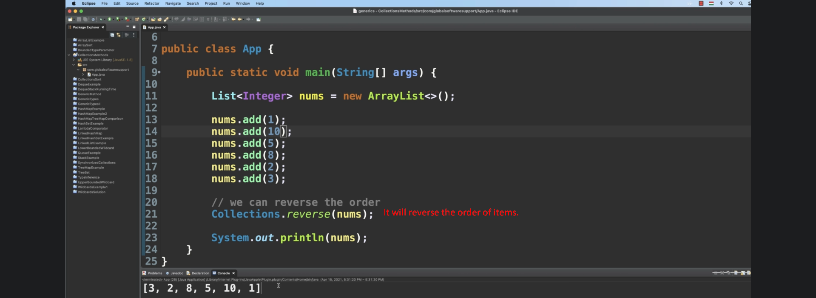
4. 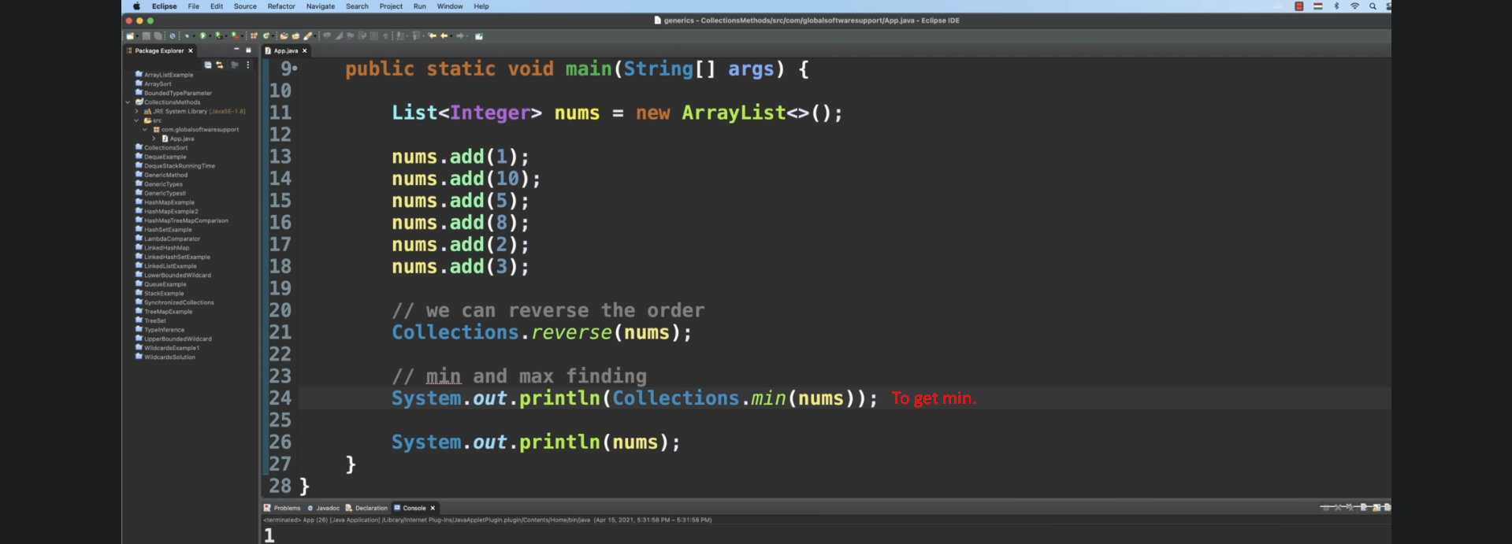
5. 